**SLIDES TESTING**

package bloodBank;

import org.openqa.selenium.By;

import org.openqa.selenium.WebDriver;

import org.openqa.selenium.chrome.ChromeDriver;

public class User {

public static void main(String[] args) {

System.setProperty("webdriver.chrome.driver", "C:\\Users\\Lenovo\\Desktop\\New

folder\\chromedriver_win32\\chromedriver.exe");

WebDriver driver = new ChromeDriver();

driver.get("http://localhost/bloodbank%20and%20donar%20management%

20system/bbdms/index.php");

driver.manage().window().maximize();

driver.findElement(By.className("carousel-control-next")).click();

String nx= driver.findElement(By.className("carousel-inner")).getText();

driver.findElement(By.className("carousel-control-prev")).click();

String pr= driver.findElement(By.className("carousel-inner")).getText();

if(pr.equalsIgnoreCase(nx))

{

System.out.println("Slide Test Succesfully Completed");

}

else

{

System.out.println("Test Not Successfull");

}

//driver.close();

}

}

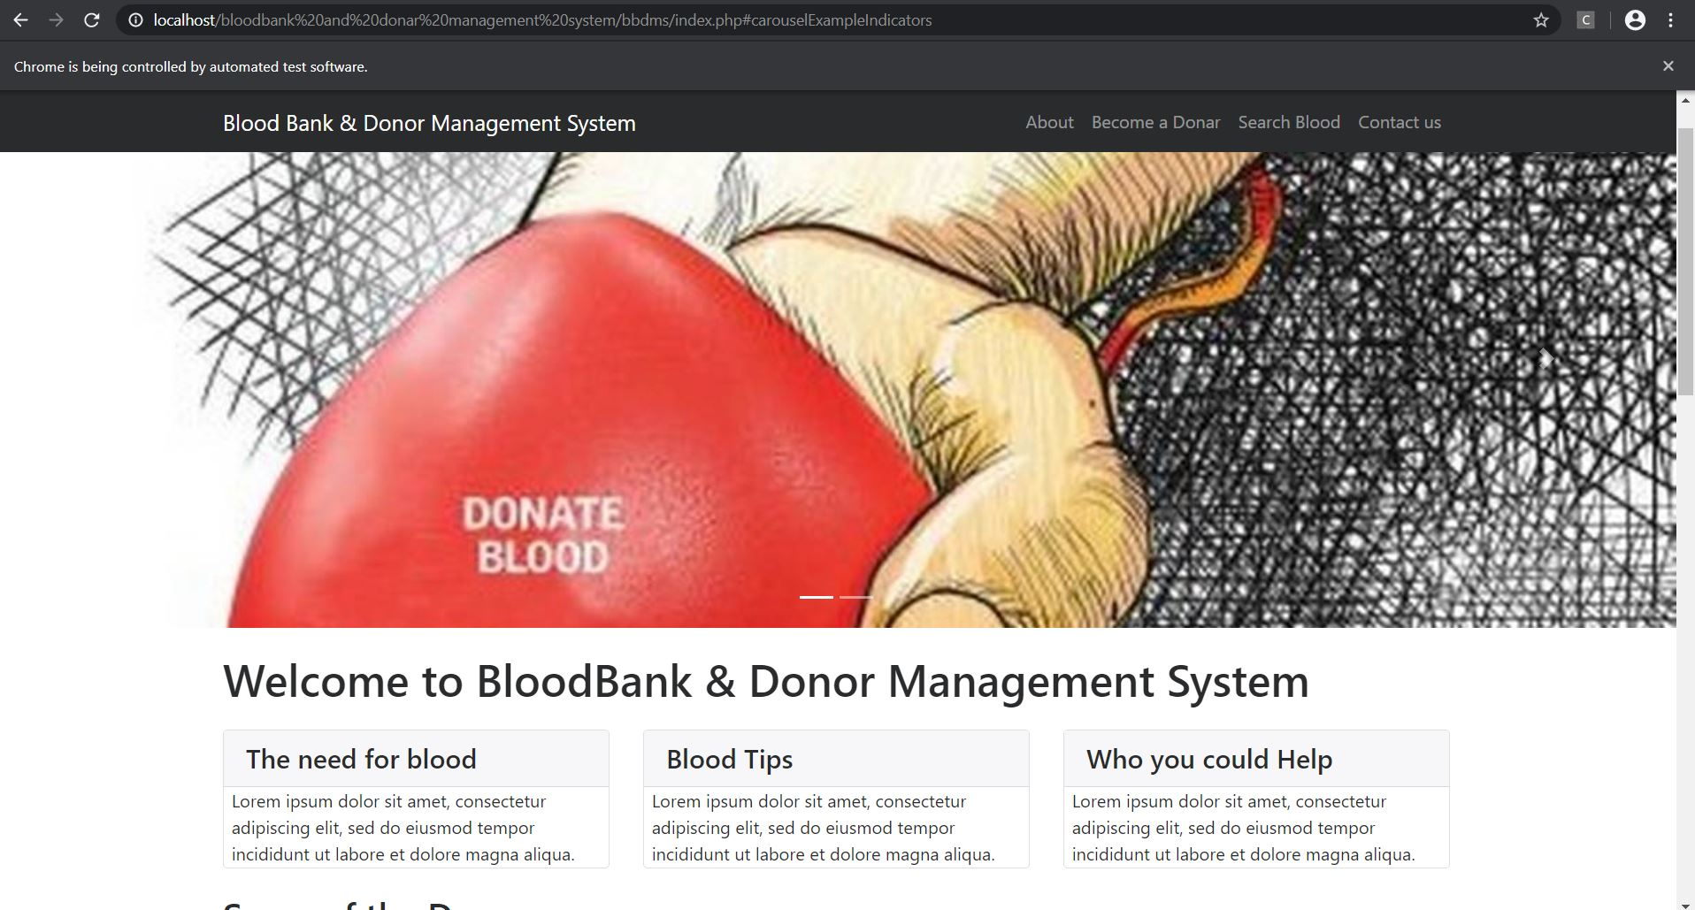

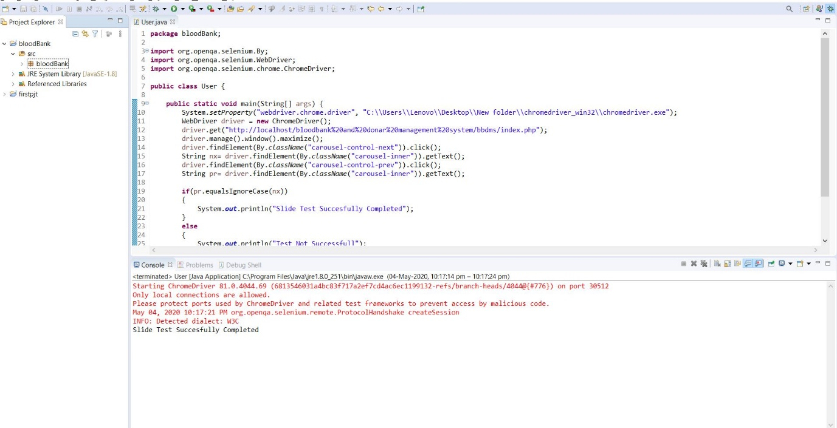

**ABOUT TESTING**

package bloodBank;

import org.openqa.selenium.By;

import org.openqa.selenium.Keys;

import org.openqa.selenium.WebDriver;

import org.openqa.selenium.chrome.ChromeDriver;

public class about {

public static void main(String[] args) {

System.setProperty("webdriver.chrome.driver", "C:\\Users\\Lenovo\\Desktop\\New

folder\\chromedriver_win32\\chromedriver.exe");

WebDriver driver = new ChromeDriver();

driver.get("http://localhost/bloodbank%20and%20donar%20management%

20system/bbdms/index.php");

driver.manage().window().maximize();

driver.findElement(By.id("a")).sendKeys(Keys.ENTER);

String x= driver.getCurrentUrl();

String y= "http://localhost/bloodbank%20and%20donar%20management%

20system/bbdms/page.php?type=aboutus";

if(x.equalsIgnoreCase(y))

{

System.out.println("About us Test Succesfully Completed");

}

else

{

System.out.println("Test Not Successfull");

}

//driver.close();

}

}

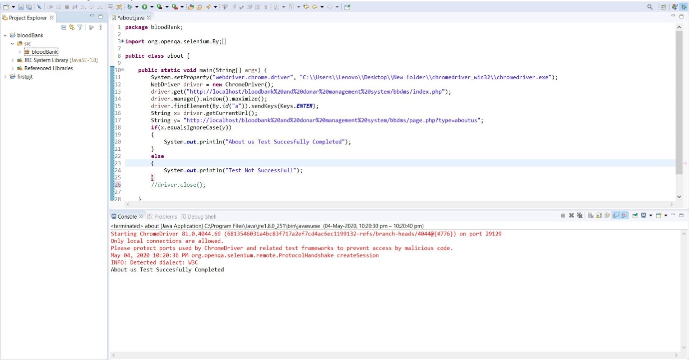

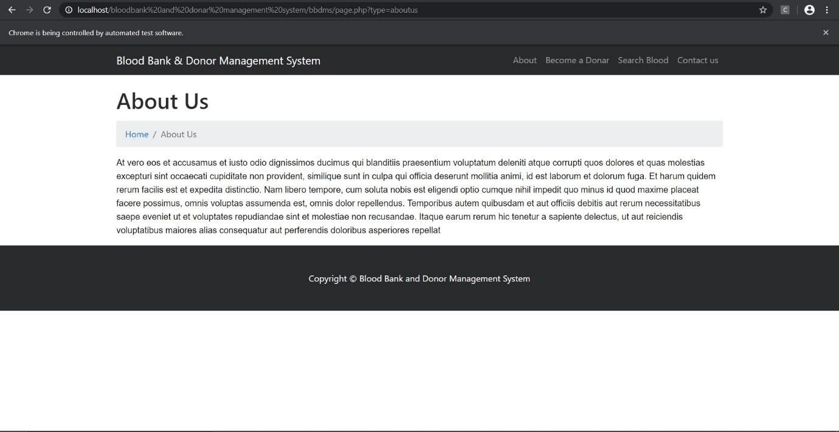

**REGISTERING A NEW DONOR**

package bloodBank;

import org.openqa.selenium.By;

import org.openqa.selenium.WebDriver;

import org.openqa.selenium.chrome.ChromeDriver;

public class doner {

public static void main(String[] args) {

System.setProperty("webdriver.chrome.driver", "C:\\Users\\Lenovo\\Desktop\\New

folder\\chromedriver_win32\\chromedriver.exe");

WebDriver driver = new ChromeDriver();

driver.get("http://localhost/bloodbank%20and%20donar%20management%

20system/bbdms/become-donar.php");

driver.manage().window().maximize();

driver.findElement(By.id("fname")).sendKeys("mm");

driver.findElement(By.id("mob")).sendKeys("9876543210");

driver.findElement(By.id("mail")).sendKeys("manjima@gmail.com");

driver.findElement(By.id("age")).sendKeys("25");

driver.findElement(By.id("add")).sendKeys("Noorumparayil");

driver.findElement(By.id("msg")).sendKeys("none");

driver.findElement(By.id("gn")).sendKeys("Female");

driver.findElement(By.id("bg")).sendKeys("A+");

driver.findElement(By.id("btn")).click();

String e= driver.findElement(By.className("succWrap")).getText();

String f= "SUCCESS:Your info submitted successfully";

if(e.equalsIgnoreCase(f))

{

System.out.println("Doner Submit Test Succesfully Completed");

}

else

{

System.out.println("Test Not Successfull");

}

//driver.close();

}

}

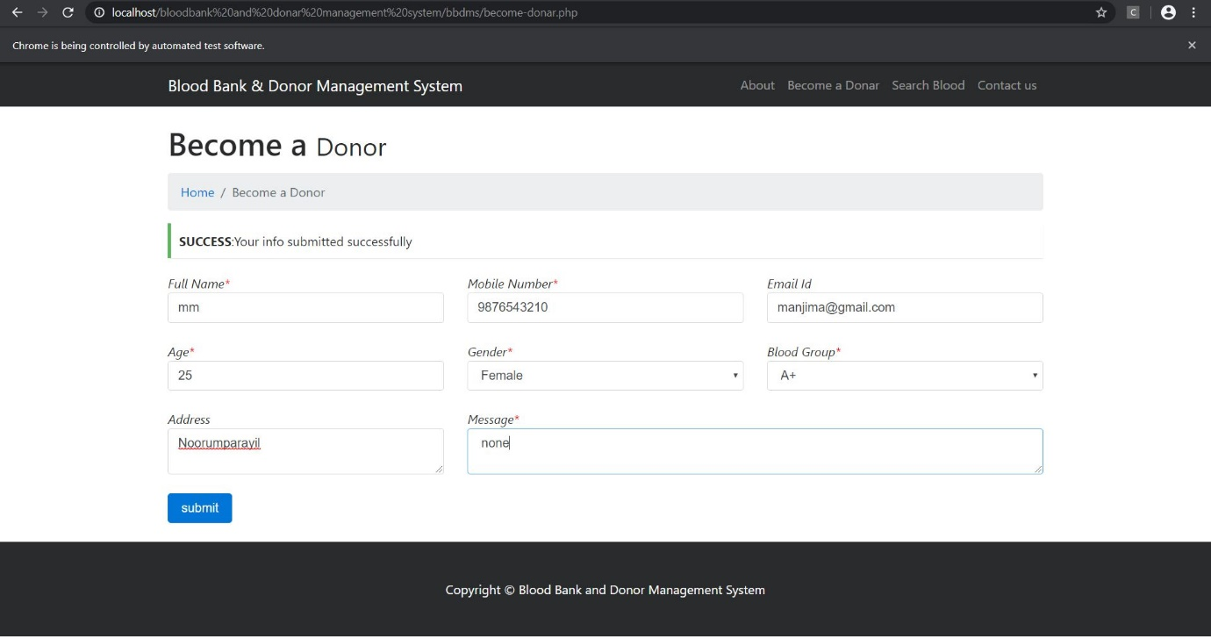

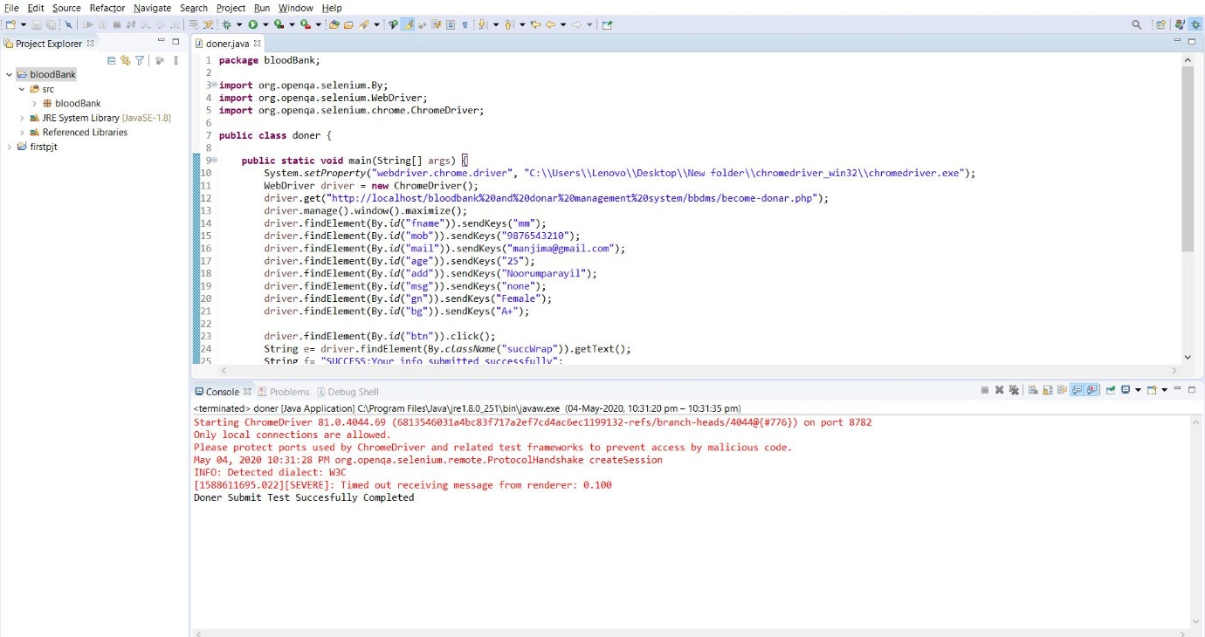

**SEARCH BLOOD**

package bloodBank;

import org.openqa.selenium.By;

import org.openqa.selenium.WebDriver;

import org.openqa.selenium.chrome.ChromeDriver;

public class search {

public static void main(String[] args) {

System.setProperty("webdriver.chrome.driver", "C:\\Users\\Lenovo\\Desktop\\New

folder\\chromedriver_win32\\chromedriver.exe");

WebDriver driver = new ChromeDriver();

driver.get("http://localhost/bloodbank%20and%20donar%20management%

20system/bbdms/search-donor.php");

driver.manage().window().maximize();

driver.findElement(By.id("opt")).sendKeys("A+");

driver.findElement(By.id("btn")).click();

String e=driver.findElement(By.id("row1")).getText();

String f= "No Record Found";

if(e.equalsIgnoreCase(f))

{

System.out.println("Test Not Successfull");

}

else

{

System.out.println("Search Test Succesfully Completed");

}

//driver.close();

}

}

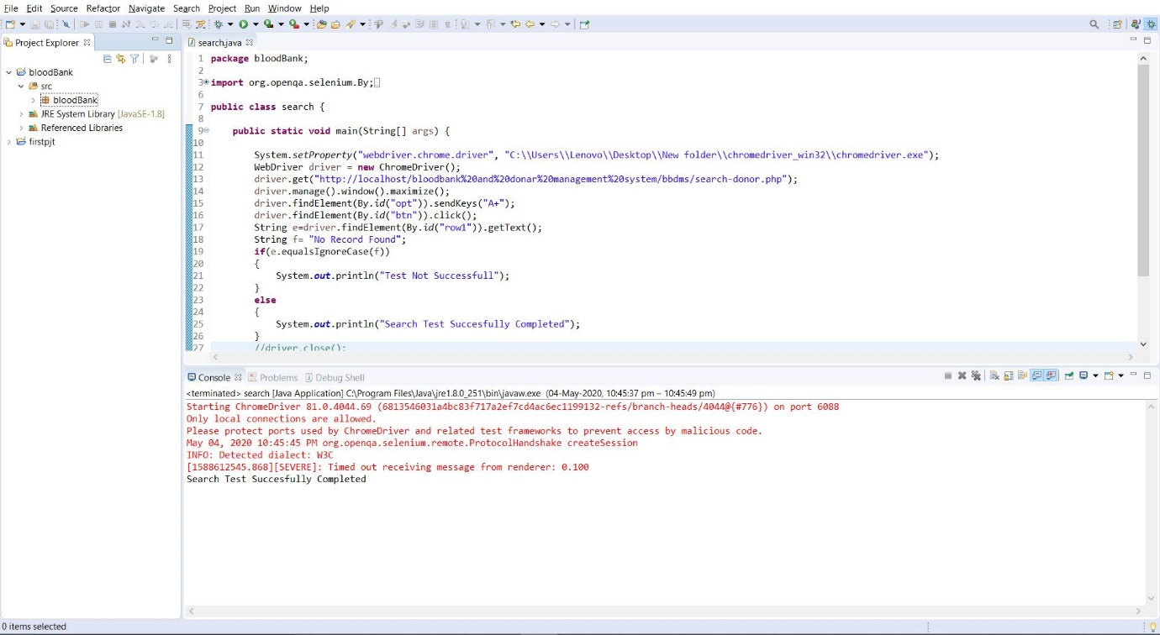

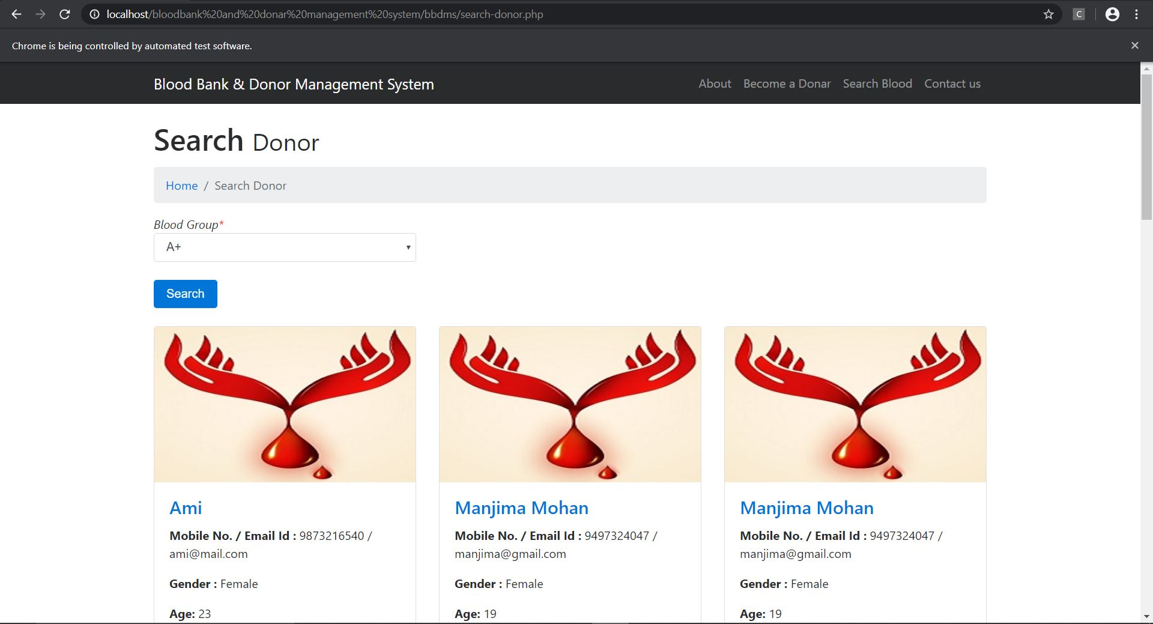

**CONTACT TESTING**

package bloodBank;

import org.openqa.selenium.By;

import org.openqa.selenium.WebDriver;

import org.openqa.selenium.chrome.ChromeDriver;

public class contact {

public static void main(String[] args) {

System.setProperty("webdriver.chrome.driver", "C:\\Users\\Lenovo\\Desktop\\New

folder\\chromedriver_win32\\chromedriver.exe");

WebDriver driver = new ChromeDriver();

driver.get("http://localhost/bloodbank%20and%20donar%20management%

20system/bbdms/contact.php");

driver.manage().window().maximize();

driver.findElement(By.id("name")).sendKeys("mm");

driver.findElement(By.id("phone")).sendKeys("9876543210");

driver.findElement(By.id("email")).sendKeys("manjima@gmail.com");

driver.findElement(By.id("message")).sendKeys("none");

driver.findElement(By.id("btn")).click();

String a= driver.findElement(By.className("succWrap")).getText();

String b= "SUCCESS:Query Sent. We will contact you shortly";

if(a.equalsIgnoreCase(b))

{

System.out.println("Contact Test Successfull");

}

else

{

System.out.println("Test Not Successfull");

}

driver.close();

}

}

